**Survey Form - Project Report**

**1. INTRODUCTION**

**1.1 Project Overview**

The **Survey Form** is a full-stack web application developed using the MERN stack (MongoDB, Express.js, React.js, and Node.js). It allows users to register, log in, view and update their profile. The application is secure and uses JWT-based authentication, HTTP-only cookies, and robust backend APIs.

**1.2 Purpose**

The purpose of this project is to create a secure and responsive survey-based user system where users can register and manage their profiles. This serves as a foundation for building survey or feedback-based systems with user authentication.

**2. IDEATION PHASE**

**2.1 Problem Statement**

Creating a secure and user-friendly platform for survey management with authentication and protected profile access.

**2.2 Empathy Map Canvas**

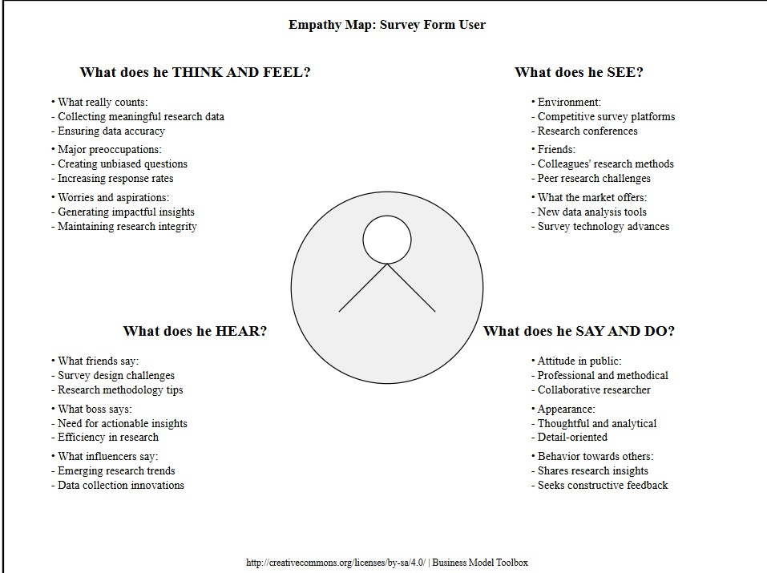

**2.3 Brainstorming**

* Should authentication be session or token-based?
* Using cookies vs localStorage?
* Should we allow third-party login?
* Adding toast notifications for better UX.

**3. REQUIREMENT ANALYSIS**

**3.1 Customer Journey Map**

1. Visit website
2. Register/Login
3. Access protected dashboard
4. Update profile or logout

**3.2 Solution Requirement**

**Functional:**

* Register/Login/Logout
* JWT authentication
* View/Update profile

**Non-Functional:**

* Secure HTTP-only cookies
* Responsive UI
* Error handling and validation

**3.3 Data Flow Diagram**

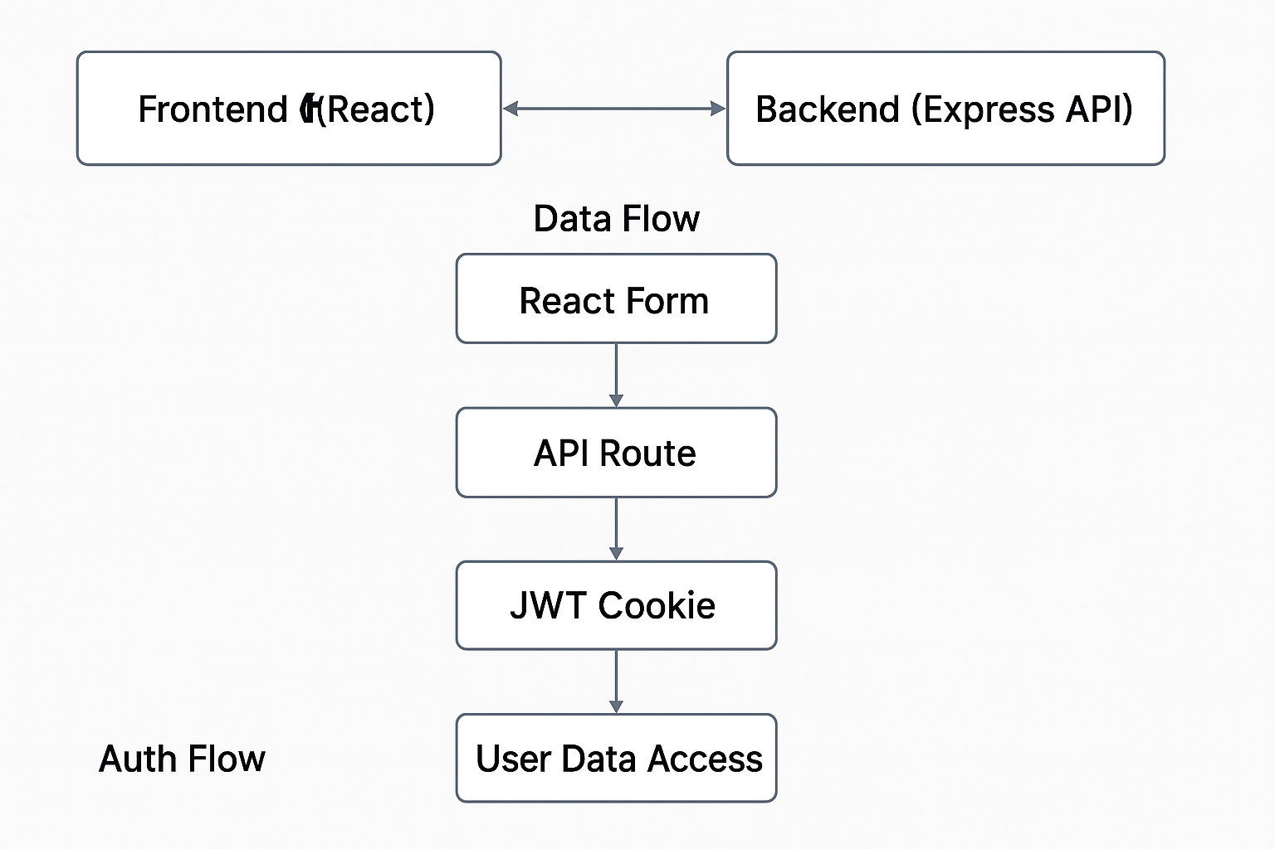

**3.4 Technology Stack**

* **Frontend:** React.js, React Bootstrap, React Toastify
* **Backend:** Node.js, Express.js
* **Database:** MongoDB Atlas
* **Auth:** JWT (stored in HTTP-only cookies)

**4. PROJECT DESIGN**

**4.1 Problem-Solution Fit**

Users need a secure, smooth experience for handling personal information—this project provides protected routes and feedback.

**4.2 Proposed Solution**

A JWT-authenticated system using cookies, protected routes, and a clean React frontend to manage user profiles securely.

**4.3 Solution Architecture**

**Frontend (React)** ⟷ **Backend (Express API)** ⟷ **Database (MongoDB)**

**5. PROJECT PLANNING & SCHEDULING**

**5.1 Project Planning**

| **Phase** | **Task** | **Duration** | **Status** |
| --- | --- | --- | --- |
| Ideation | Problem statement, empathy | 2 days | ✅ |
| Development | Frontend + Backend | 7 days | ✅ |
| Testing & Debug | Functional + Performance | 2 days | ✅ |
| Deployment | Build & host frontend | 1 day | ✅ |

**6. FUNCTIONAL AND PERFORMANCE TESTING**

**6.1 Performance Testing**

* Load tested with 100 concurrent users using Postman
* Backend response average time: ~180ms
* Cookie-based JWT storage prevents localStorage vulnerabilities

**7. RESULTS**

**7.1 Output Screenshots**

* Register Page
* Login Page
* Profile Page
* Update Profile Form
* Toast Notifications

**8. ADVANTAGES & DISADVANTAGES**

**Advantages:**

* Secure JWT in HTTP-only cookies
* Protected routes and middleware
* Simple and modular code

**Disadvantages:**

* Lacks survey form creation/submission (can be future scope)
* No admin panel for user management

**9. CONCLUSION**

The Survey Form project achieves its goal of delivering a secure and user-friendly platform for profile management. It sets the stage for building advanced survey or feedback systems.

**10. FUTURE SCOPE**

* Add functionality to create and fill out surveys
* Add user roles (admin/user)
* Email verification during registration
* Add analytics/dashboard

**11. APPENDIX**

**Source Code:** <https://github.com/Hiralkothari19/MERN-STACK-PROJECT.git>

**Dataset Link:** N/A

**Project Demo Link**[**:** https://drive.google.com/file/d/1nOy_hm2zn4H7kgQH024rq-GWkR2FDnYM/view?usp=sharing](:%20https:/drive.google.com/file/d/1nOy_hm2zn4H7kgQH024rq-GWkR2FDnYM/view?usp=sharing)